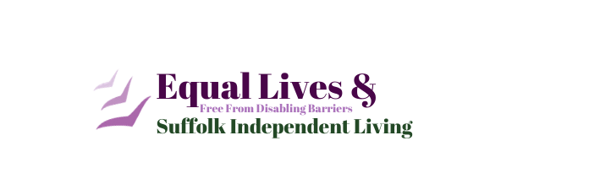

Your address

Your MP name
(you can find this here: https://members.parliament.uk/FindYourMP)
House of Commons
London
SW1A 0AA

DATE

Dear MP name
RE: Face Mask Exemption
As a member of your constituency, I am writing to express concern regarding the law and guidance around face masks and exemption, during the COVID19 pandemic.
For those of us who are exempt from wearing a face mask in shops or anywhere they’re required; it is difficult to obtain recognised exemption that is accepted by security, shop assistants, bus drivers etc.
This is causing many issues for us, as we’re experiencing discrimination and unfair or inconsistent treatment.
Getting an exemption letter from a GP can be difficult to obtain; however even once received – it doesn’t appear adequate and there is little alternative.
I’m a member of Equal Lives, and they have advised of the following issues from members:
- Difficulty obtaining GP letters
- Regularly having to show proof, even on every visit to the same place where the same people are checking
- Can still be refused entry even with proof
- Judgement in society and anxiety triggers
- Having to discuss disability or exemption with strangers
- Flower lanyards for invisible disabilities still not widely recognised

Add any personal experience, e.g what has happened to you or someone you know

I am interested to know
- What action is the government taking to address the above issues?
- Is the government working on an official exemption list, in the same way they have for shielding people?
- Are there plans to bring in an official card or exemption proof method?
- Will there be guidance or a campaign to demonstrate what action businesses should take when dealing with those exempt from wearing masks

I welcome your views on this issue and I hope you agree you constituents would benefit from improved support on this matter. It is not fit for purpose and I hope you will work with your constituency to get feedback from us, the affected people as to how to proceed.

Yours Sincerely,

Your name
Template provided by Equal Lives
https://www.equallives.org.uk/
01508 491 210
membership@equallives.org.uk

